**Outline for Lines 150-250**

First 150 lines was to set parameters (for both simulation and data storage)

Simulation: simulation time, assignment iteration, interval, start time/interval, and end time/interval

Data storage: nodes, links, agents, arrivals, and departures

**Global data**

Define global variables across different functions (Figure 1)

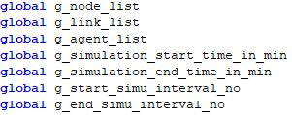

Figure 1 global variable definition

* **Read input data**

node.csv, link.csv, and demand.csv files

* 1. Number of nodes
     + Node ID
  2. Number of links
     + From and to nodes
     + Length, lanes, free speed, capacity, link type, VDF coefficients
  3. Number of agents
     + Agent ID
     + Agent type, origin/ destination nodes, departure time

1. Check if origin and destination nodes are defined
2. Check if origin and destination nodes are correct
3. Initialize the agent
4. Update the simulation time
5. Add the agent to the agent list
6. Sort agents by the departure time
7. Start simulation interval

**Outline for Lines 250-350**

**Shortest Path Generation**

Network class for generating shortest path

Initialize self attributes for traffic assignment (Figure 2)

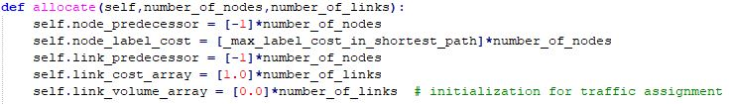

Figure 2 self attributes definition

* **Traffic Assignment Module**

Shortest Path Tree Generation (Figure 3)



Figure 3 Shortest Path Tree Initialization

Flow Assignment (Figure 4)

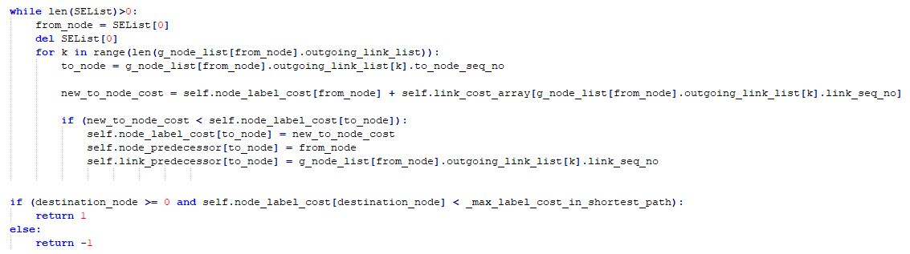

Figure 4 Link Flow

* Two loops across all links to check for available road and vehicle carrying capacity. From link cost according to the BPR function, find the shortest path for the corresponding agents, and then update the link volume
  1. Determine if the shortest path needs to be generated
  2. Build the Shortest Path Tree
  3. Update path
  4. Compute the link volume from scanning the shortest path